**Lab Report**

**Pundra University of Science & Technology**

Course Code: CSE 2206

Course Title: Computer Architecture & Organization Sessional

Project Title: 4-Bit Arithmetic Logic Unit (ALU) Using Logisim

**Submitted By:**

Arafat Rahman

ID: 0322310105101052

Session: Summer-2024

Semester: 4th, Batch: 22nd

**Submitted To:**

Iffath Tanjim Moon

Designation: Lecturer

Department: Dept of CSE

TABLE OF CONTENTS

1. Abstract
2. Introduction
3. Objectives
4. Tools and Software
5. Design Description
   1. Components Used
   2. Design Overview
6. Implementation
   1. Design Steps
   2. Circuit Diagram
   3. Function Table
7. Working Mechanism
8. Challenges and Solutions
9. Conclusion
10. References

1. ABSTRACT

This report presents the design and implementation of an Arithmetic and Logic Unit (ALU) using Logisim, a widely used tool for digital circuit simulation. The ALU is a critical component of modern computer architecture, responsible for performing arithmetic operations such as addition and subtraction, as well as logical operations like AND, OR, and NOT. The project integrates two main units: an Arithmetic Unit and a Logic Unit, controlled by a toggle switch. A control signal determines whether the ALU performs arithmetic or logical operations, ensuring seamless switching between the units. The design leverages multiplexers, basic logic gates, and a control unit for operational efficiency. Simulation results validate the ALU's functionality, demonstrating accurate outputs for various input combinations. This project underscores the importance of ALUs in computational systems and provides a foundational understanding of digital circuit design.

2. INTRODUCTION

The project involves designing an Arithmetic and Logic Unit (ALU) using Logisim, which is a key component of a computer processor. The ALU is responsible for performing arithmetic operations (e.g., addition, subtraction) and logical operations (e.g., AND, OR, NOT). The objective of this project is to create an ALU that can switch between Arithmetic and Logic operations based on a control signal.

3. OBJECTIVES

* To design a functional ALU integrating Arithmetic and Logic operations.
* To implement a control mechanism using a toggle button to switch between Arithmetic and Logic modes.
* To validate the ALU's operation using various input combinations.

4. TOOLS AND SOFTWARE

* **Software Used:** Logisim
* **System Requirements:**

**Software**: Java Runtime Environment (if required for Logisim)

5. DESIGN DESCRIPTION

**5.1. Components Used:**

* **Arithmetic Unit:** Includes adders, subtractors, and multiplexers.
* **Logic Unit:** Implements logical operations such as AND, OR, and NOT.
* **Control Unit:** Uses a toggle button (control signal) to switch between the units.
* **Multiplexers:** For selecting between Arithmetic and Logic outputs.
* **LEDs:** For displaying outputs.

**5.2. Design Overview:**

The ALU integrates both units, with their outputs routed to a multiplexer. A control signal, implemented using a toggle button, determines whether the Arithmetic or Logic Unit is active:

* **Control Signal = 0 (Off):** Arithmetic Unit is active.
* **Control Signal = 1 (On):** Logic Unit is active.

6. IMPLEMENTATION

**6.1. Design Steps:**

1. Arithmetic Unit Design: Implement operations such as addition and subtraction using basic gates and multiplexers.  
2. Logic Unit Design: Configure gates for AND, OR, and NOT operations.  
3. Control Integration: Use a toggle button to create a control signal.  
4. Multiplexing: Combine outputs from both units and connect to the multiplexer, controlled by the toggle signal.  
5. Testing: Validate individual components before integrating the entire circuit.

**6.2. Circuit Diagram**

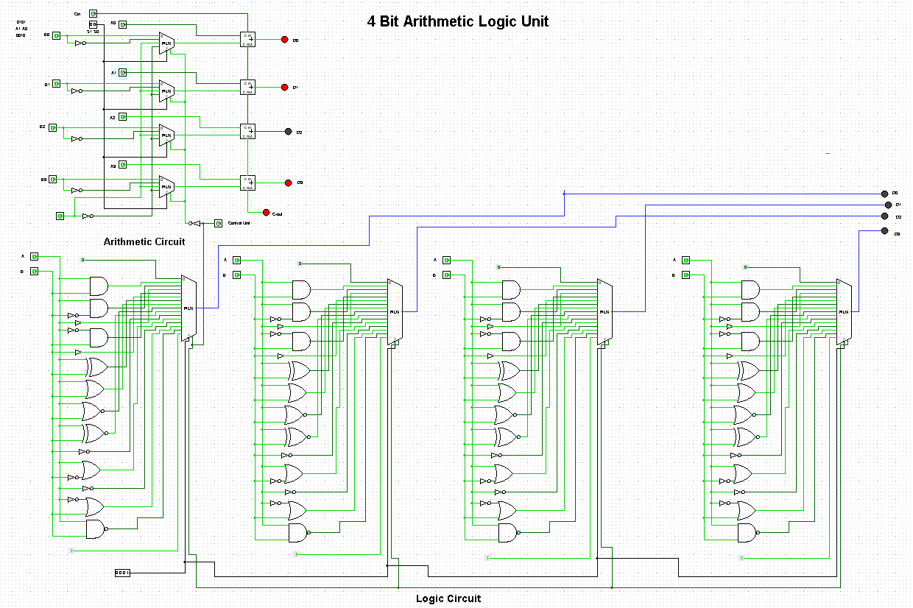

Figure: 4-Bit Arithmetic Logic Unit (ALU)

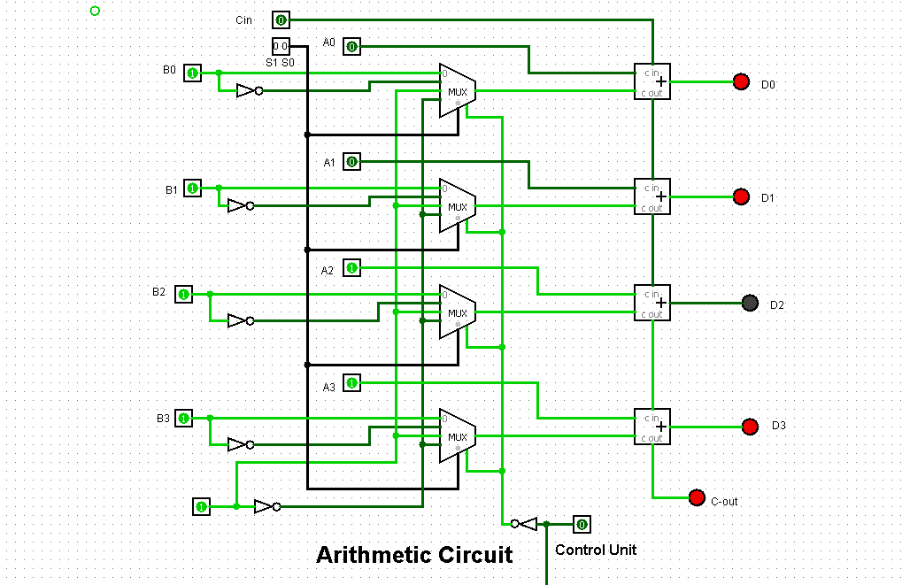

Figure: 4-Bit Arithmetic Circuit

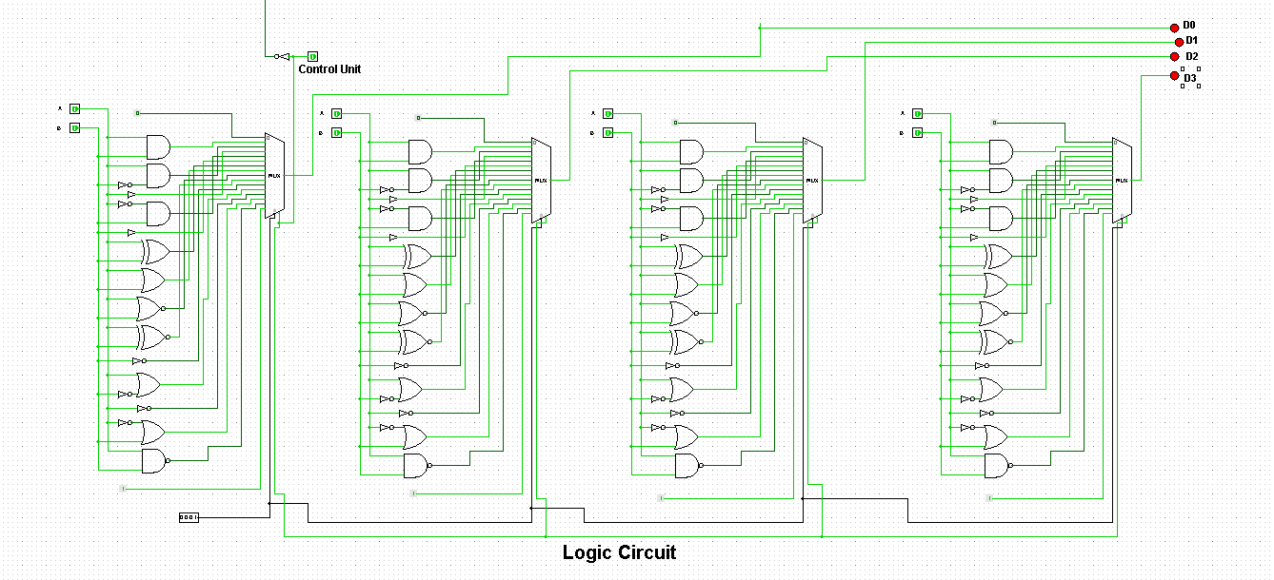

Figure: 4-Bit Logic Unit

**6.3. Function Table:**

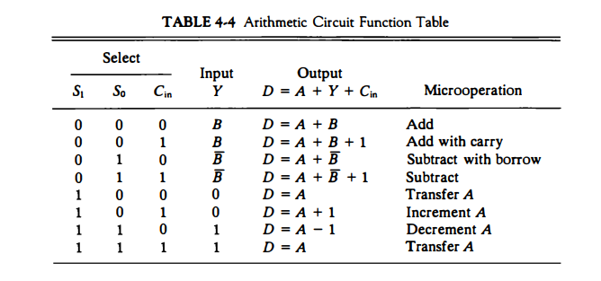

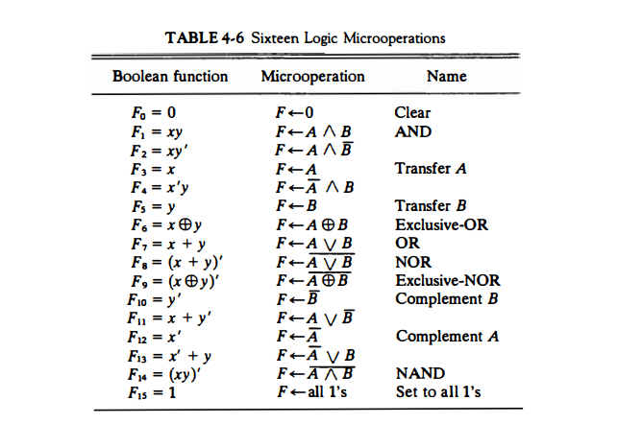

7. WORKING MECHANISM

**1. Arithmetic Unit:**  
 - Performs addition and subtraction based on the input and generates the results.  
 - Activated when the control signal is 0 (toggle button is off).  
**2. Logic Unit:**  
 - Executes logical operations such as AND, OR, and NOT.  
 - Activated when the control signal is 1 (toggle button is on).  
**3. Control Signal:**  
 - The toggle button controls the select line of the multiplexer to switch between Arithmetic and Logic Units.

8. CHALLENGES AND SOLUTIONS

* **Challenge:** Configuring the toggle button to correctly switch the multiplexer.
* **Solution:** Debugged the circuit by testing the toggle signal's propagation to the multiplexer select line.
* **Challenge:** Managing wiring complexity.
* **Solution:** Organized the design into distinct sections and labeled connections clearly.

9. CONCLUSION

The ALU was successfully designed and implemented in Logisim. The control signal effectively switches between Arithmetic and Logic Units, and the outputs were verified against expected results. Future work could expand the ALU with additional operations such as multiplication or division.

10. REFERENCES

1. **Logisim Documentation**

URL: <http://www.cburch.com/logisim/>

1. **M. Morris Mano and Michael D. Ciletti, "Digital Design"**

A foundational text on digital logic design, covering gates, multiplexers, and arithmetic unit design.

Publisher: Pearson Education

ISBN: 978-0132774208

1. **TutorialsPoint: Digital Logic Design**

An online resource for learning about digital circuits, including the design of arithmetic and logic units.

URL: <https://www.tutorialspoint.com/digital_circuits/index.htm>